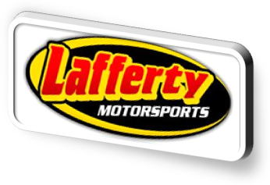NASCAR SpeedPark® to Be Primary Sponsor of Chris Lafferty (No. 89) In CWTS Race at Charlotte
Wednesday, May 4, 2011

(CONCORD, N.C.)- Lafferty Motorsports announced Wednesday that it has joined forces with “The Official Family Fun Park of NASCAR®”. NASCAR SpeedPark® will serve as primary sponsor of Camping World Truck Series driver Chris Lafferty’s No. 89 entry in the N.C. Education Lottery 200 at Charlotte on May 20, 2011.

Lafferty will also be making several appearances at NASCAR SpeedPark® locations around the country. During Charlotte “Speedweek,” Lafferty will be at the NASCAR SpeedPark® in Concord on Friday, May 27th and Saturday, May 28th. Lafferty will be signing autographs, giving away prizes and doing a pit-stop challenge with fans. Guests will have an opportunity to enter to race against Lafferty on one of the go-kart tracks during the event.

“We are excited to have NASCAR SpeedPark® on board for our Charlotte race,” says Lafferty. “NASCAR SpeedPark® is a great company which offers so much for both people and communities.” Lafferty went on to say that he loves to take his daughter to NASCAR SpeedPark® for a day of fun, when he’s not racing.

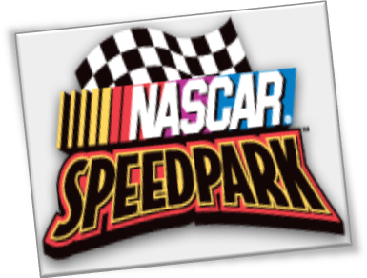NASCAR SpeedPark®, owned and operated by PARC Management, is a racing-themed amusement park that bridges the gap between family amusement venues and the professional NASCAR® racing circuit. NASCAR SpeedPark® is an officially licensed property of the National Association for Stock Car Auto Racing and allows guests to experience the excitement of NASCAR® by featuring five challenging racetracks.

“Sponsoring Lafferty Motorsports is a unique opportunity for NASCAR SpeedPark®, as it brings together our NASCAR®-themed family entertainment venues with a quality NASCAR® Camping World Truck Series driving team. We are thrilled to be able to provide our park guests with the opportunity to meet drivers and view actual racing trucks as part of their experience in our parks,” said Doug Anderson, President of PARC Management.
NASCAR SpeedPark® locations offer a variety of family entertainment including miniature golf, rock wall climbing, arcades, family and thrill rides, NASCAR®-branded merchandise stores, and more. The combination of rides, attractions and entertainment makes NASCAR SpeedPark® full-throttle family fun from start to finish.

NASCAR SpeedPark® has four locations in the United States and one in Canada. Lafferty will be appearing at NASCAR SpeedPark®- St. Louis, MO on Wednesday, June 1st, NASCAR SpeedPark®- Myrtle Beach, SC on Sunday, June 19th and NASCAR SpeedPark®– Sevierville, TN on Friday, June 24th. Visit www.nascarspeedpark.com or Facebook for more details.

About Lafferty Motorsports
Lafferty Motorsports is primarily involved in the NASCAR Camping World Truck Series. Besides racing, the Concord, N.C. based team has an elite engine building program and a proven driver development program. Lafferty has begun a new, late-night TV show titled “The Last Lap with Chris Lafferty.” Lafferty will film three live shows in the Charlotte-area during May. Visit www.laffertymotorsports.net or Facebook Chris Lafferty for more information.

About NASCAR SpeedPark®
The “Official Family Fun Park of NASCAR®”, NASCAR SpeedPark’s five exciting locations in Myrtle Beach, S.C., Concord, N.C., Sevierville, Tenn., St. Louis, Mo. and Toronto, Ontario, are among North America’s top tourist attractions. Owned and operated by PARC Management, LLC, NASCAR SpeedParks offer race-themed go-kart tracks, miniature golf, kids’ rides, family thrill rides, rock wall climbing, arcades and more. www.NASCARSpeedPark.com

About PARC Management, LLC
PARC Management, LLC operates five NASCAR SpeedParks across the U.S., Myrtle Waves Water Park in Myrtle Beach, S.C., Pavilion Nostalgia Park and Carousel Park in Myrtle Beach, S.C., and also offers management and consulting services to third‐party private and governmental owners of entertainment venues including: parks, attractions, stadiums, arenas, theaters, museums, amphitheaters, and entertainment centers. PARC owns the international development rights to NASCAR SpeedPark®. www.PARCManagement.com

-LAFFERTY MOTORSPORTS PRESS RELEASE

